Step-Distillation 20251127-1204

一，Loss修改
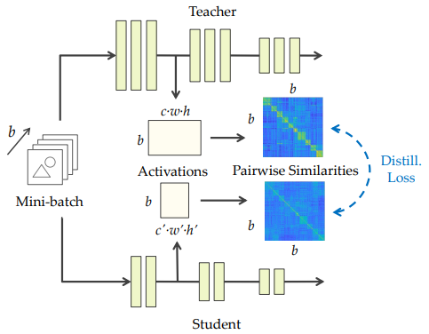

1. 图像 SP Loss (原论文)
$L_{total}=L_{Class_CE}+γL_{SP}\left(Flatten\left(CNN_Feats\right)\right)$

2. 扩散 LM SP Loss
$L_{total}=L_{Token_CE}+γL_{SP}\left(Flatten\left(Masked_Transformer_Feats\right)\right)$

二，训练结果

1. SP Loss
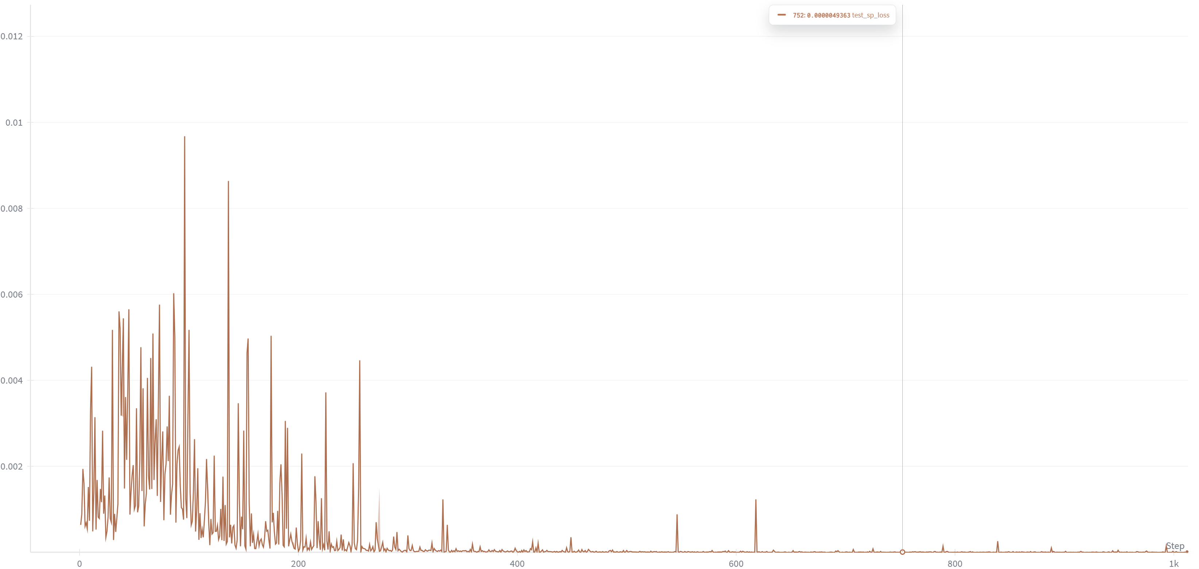

1.1 CheckPoint384
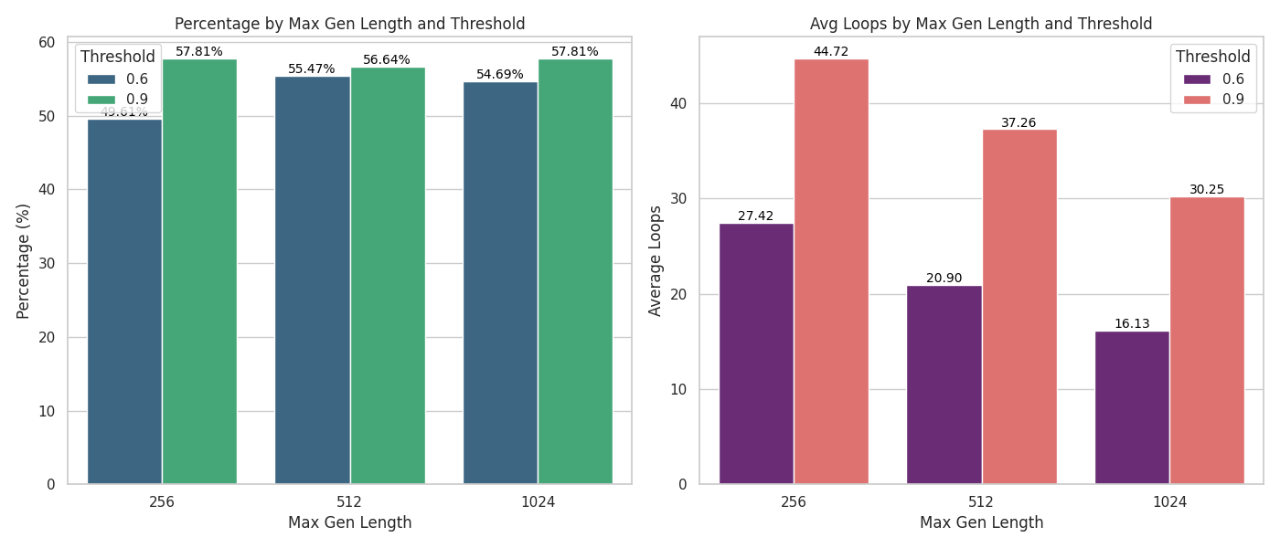

1.2 CheckPoint1024
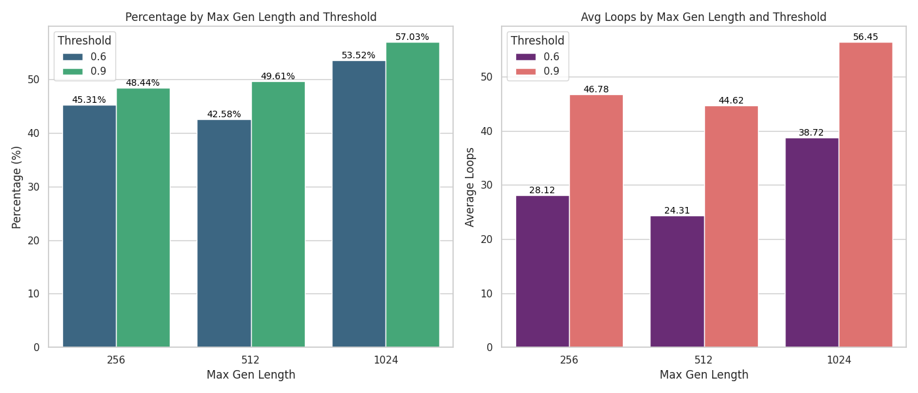

2. total Loss
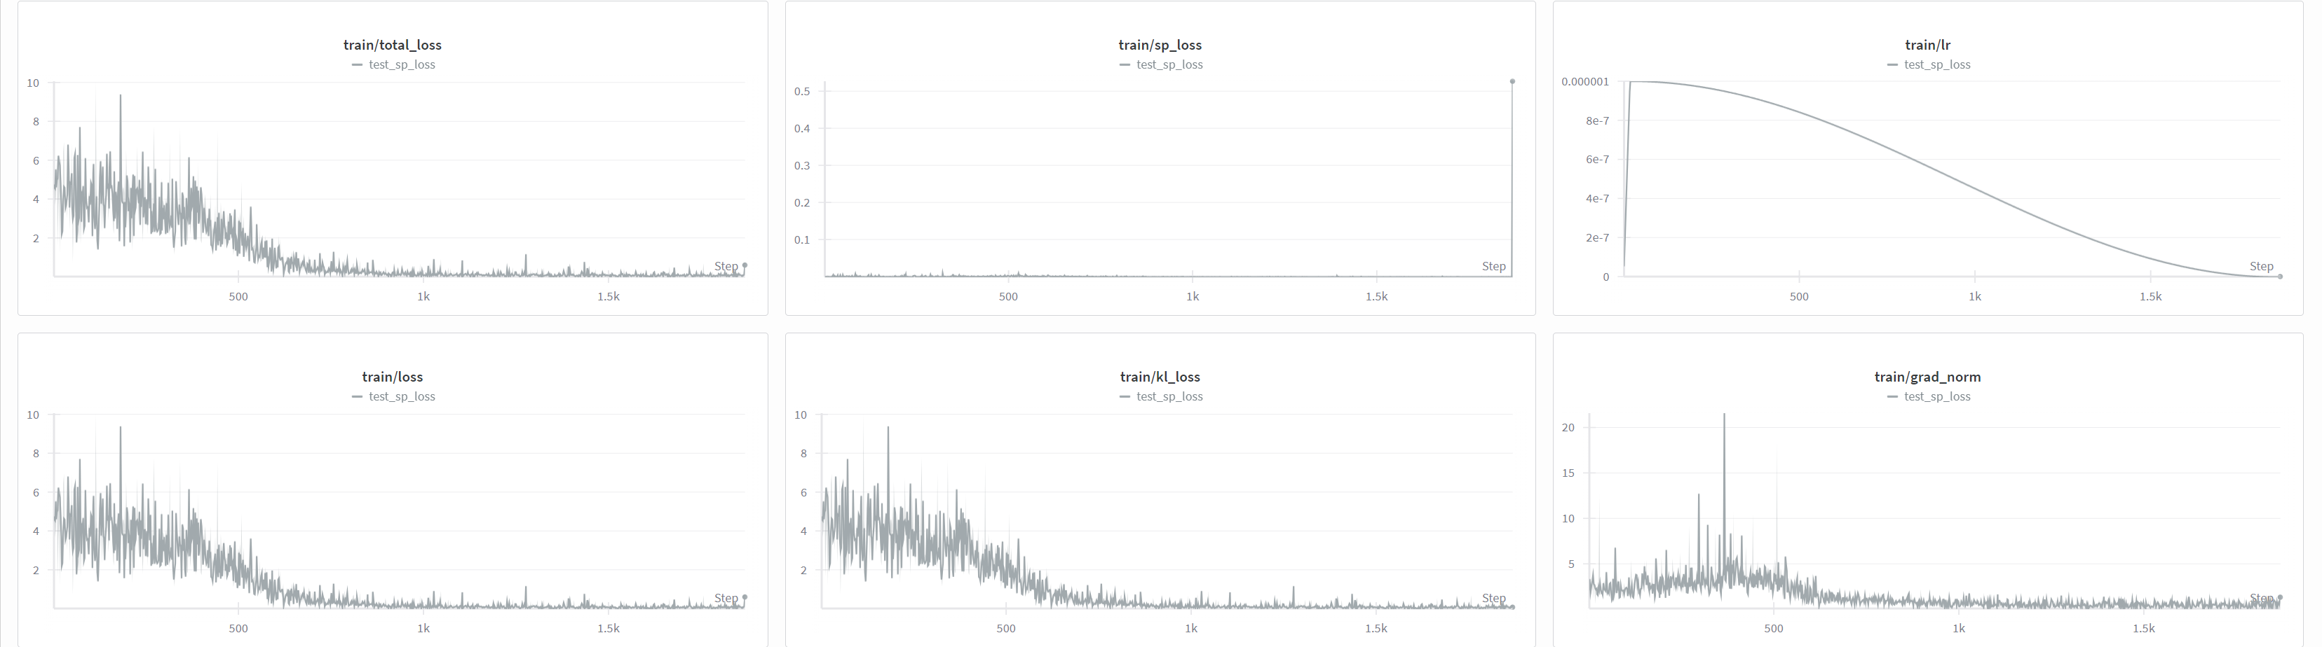

2.1 CheckPoint384
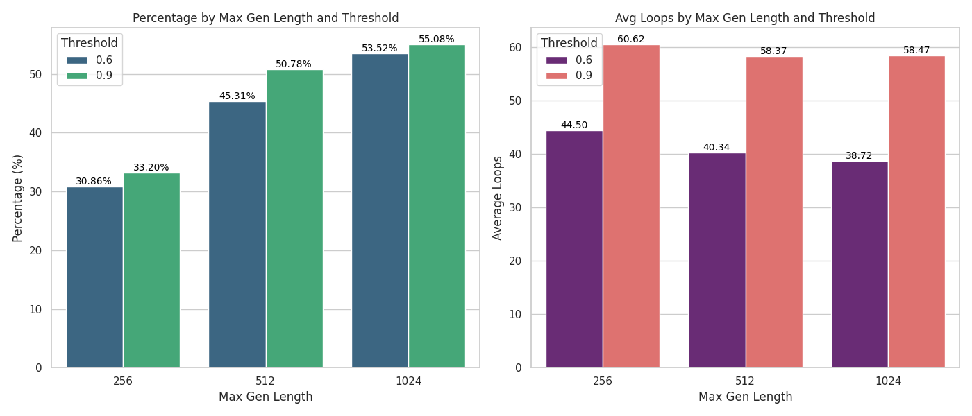

2.1 CheckPoint1024
